**Air Quality Index Prediction and Analysis Report**

Introduction  
Air quality monitoring and prediction have become crucial components of urban planning, public health management, and environmental policy-making. This project addresses the growing need for accurate air quality forecasting systems that can help businesses and organizations make informed decisions about their operations and environmental impact. Poor air quality costs businesses billions annually through reduced productivity, increased healthcare costs, and regulatory compliance issues. The implementation of predictive air quality models can provide valuable lead time for businesses to adjust operations, protect employee health, and optimize energy consumption, ultimately leading to cost savings and improved corporate social responsibility.

# Objectives

1. Develop and compare multiple deep learning models for accurate AQI prediction
2. Analyze temporal patterns and pollutant contributions to air quality
3. Provide actionable insights for business decision-making and urban planning
4. Evaluate WHO guideline compliance and identify critical intervention periods

# Development Process and Analysis Report

Initial Setup and Data Processing  
The program began with importing essential libraries including pandas, NumPy, matplotlib, seaborn, and various machine learning components from scikit-learn and TensorFlow. The data was loaded from 'city_day.csv' and underwent preprocessing, including datetime conversion and handling missing values through mean imputation. The program created temporal features by extracting year, month, and day from the dates.

1. Model Architecture Development  
   Three distinct deep learning models were implemented for AQI prediction:
2. A Long Short-Term Memory (LSTM) model with two LSTM layers (64 and 32 units) followed by dense layers
3. A hybrid CNN-LSTM model combining convolutional layers for feature extraction with LSTM layers for temporal processing
4. A Transformer model utilizing multi-head attention mechanisms with 4 attention heads
5. Data Preparation and Training

The features were scaled using MinMaxScaler, and time series sequences were created with a 30-day window. The dataset was split into training and testing sets (80:20 ratio). All models were compiled using the Adam optimizer and Mean Squared Error loss function, then trained for 10 epochs with a batch size of 50.

1. Model Performance Analysis

The LSTM model emerged as the best performer with an MSE of 3925.33 and R² score of 0.773, followed by the CNN-LSTM hybrid (MSE: 4885.19, R²: 0.717) and the Transformer model (MSE: 5292.96, R²: 0.694). This indicates that the LSTM architecture was most effective at capturing the temporal patterns in air quality data.

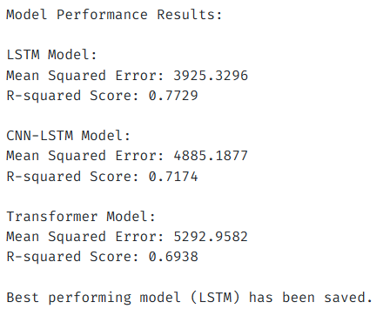

1. Temporal Pattern Analysis

The analysis revealed significant seasonal patterns in air quality. November showed peak AQI levels while July recorded the lowest levels. The pie chart in the output image shows the distribution of AQI categories, with Moderate conditions accounting for 35.5% and Satisfactory conditions at 33.1% of the observations. The yearly trend graph demonstrates a general improvement in air quality from 2015 to 2020.

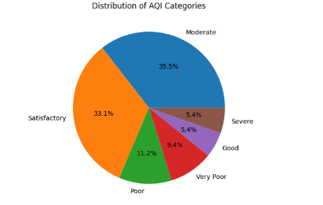

1. Pollutant Impact Assessment

Carbon Monoxide (CO) showed the strongest correlation with AQI (0.650), followed by PM2.5 (0.629) and NO2 (0.523).

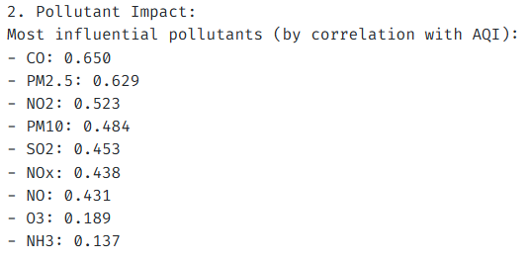

The WHO guideline exceedance analysis revealed that PM10 exceeded safety thresholds most frequently (67.1% of days), followed by PM2.5 (48.5%). These findings highlight the significant impact of particulate matter on overall air quality.

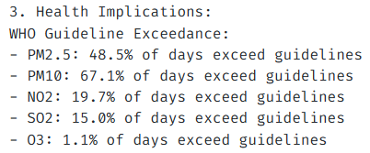

Final Implementation and Documentation  
The program concluded with comprehensive visualization of results, including training histories, performance comparisons, and temporal patterns. The best-performing model was saved for future use, and detailed findings were documented in 'air_quality_analysis_findings.txt'. The program also generated visualization outputs showing AQI distributions, temporal patterns, and pollutant correlations.

The findings suggest that while air quality has shown improvement over the years, particular attention should be paid to controlling particulate matter and carbon monoxide emissions. The success of the LSTM model indicates strong temporal dependencies in air quality patterns, which could be valuable for future prediction and planning purposes.

Model Selection justification  
The choice of three distinct deep learning architectures was strategic:

* LSTM was selected for its proven capability in handling time series data and capturing long-term dependencies in environmental patterns
* CNN-LSTM hybrid was implemented to leverage both spatial feature extraction and temporal pattern recognition
* Transformer model was included to test the effectiveness of attention mechanisms in capturing complex air quality relationships

The LSTM model's superior performance (MSE: 3925.33, R²: 0.773) can be attributed to its ability to maintain long-term memory of seasonal patterns and pollutant interactions. This makes it particularly suitable for air quality prediction where historical patterns strongly influence future values.

Business Insights and Applications  
This project provides several key benefits for businesses:

1. Risk Management: Companies can anticipate poor air quality days and adjust outdoor operations accordingly
2. Healthcare Cost Reduction: Preventive measures can be implemented during predicted high-pollution periods
3. Regulatory Compliance: Businesses can proactively manage emissions during critical periods
4. Resource Optimization: HVAC systems and air purification resources can be managed more efficiently based on predictions
5. Corporate Planning: Long-term facility locations and expansion plans can consider air quality trends

Conclusion  
The developed AQI prediction system demonstrates robust performance, with the LSTM model emerging as the most reliable predictor. The analysis reveals significant improvements in air quality from 2015 to 2020, though challenges remain with particulate matter and carbon monoxide levels. The findings provide a foundation for data-driven decision-making in environmental management and urban planning.

For businesses, this project offers a valuable tool for both operational optimization and strategic planning. The ability to predict air quality with reasonable accuracy enables proactive rather than reactive approaches to environmental challenges. The temporal patterns and pollutant analysis provide crucial insights for scheduling sensitive operations and implementing targeted emission control measures.

Future enhancements could include real-time prediction capabilities, integration with weather data, and development of business-specific risk metrics. The success of the LSTM model suggests that focusing on temporal pattern recognition in future developments could yield even more accurate predictions.

The project demonstrates that advanced analytics can bridge the gap between environmental monitoring and business decision-making, providing both economic and social benefits. As environmental concerns continue to grow, such predictive tools will become increasingly valuable for sustainable business operations and urban development.